
Pool Car Inspection au

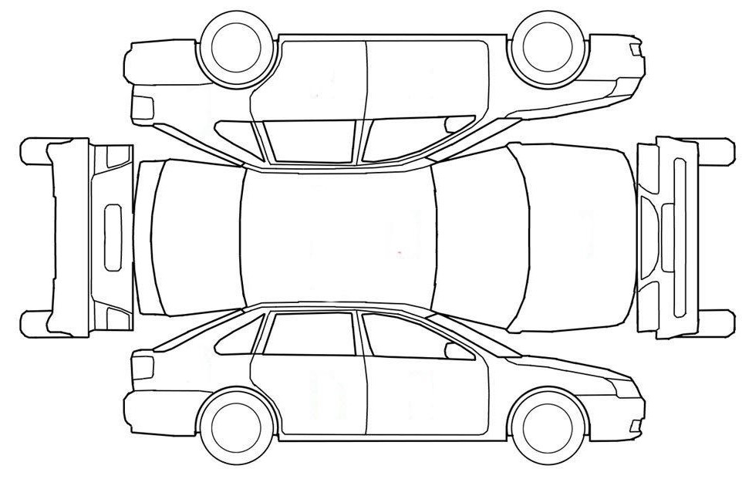

PLEASE CHECK ANY EXISTING DAMAGES OTHER THAN MINOR DEFECTS. AUXILIARY SERVICES DEPARTMENT SHOULD BE NOTIFIED IF ADDITIONAL DAMAGES FOUND.

DRIVER’S SIGNATURE………………………………………DATE…………………………………

VEHICLE INSPECTED BY……………………... DATE…………………………………

DATE/ TIME (DEPARTURE).…………………..DATE & TIME ( ARRIVAL)………

